The Battle of Neighborhoods: Coursera Capstone Project:

Middle East Restaurant in Manhattan,NY

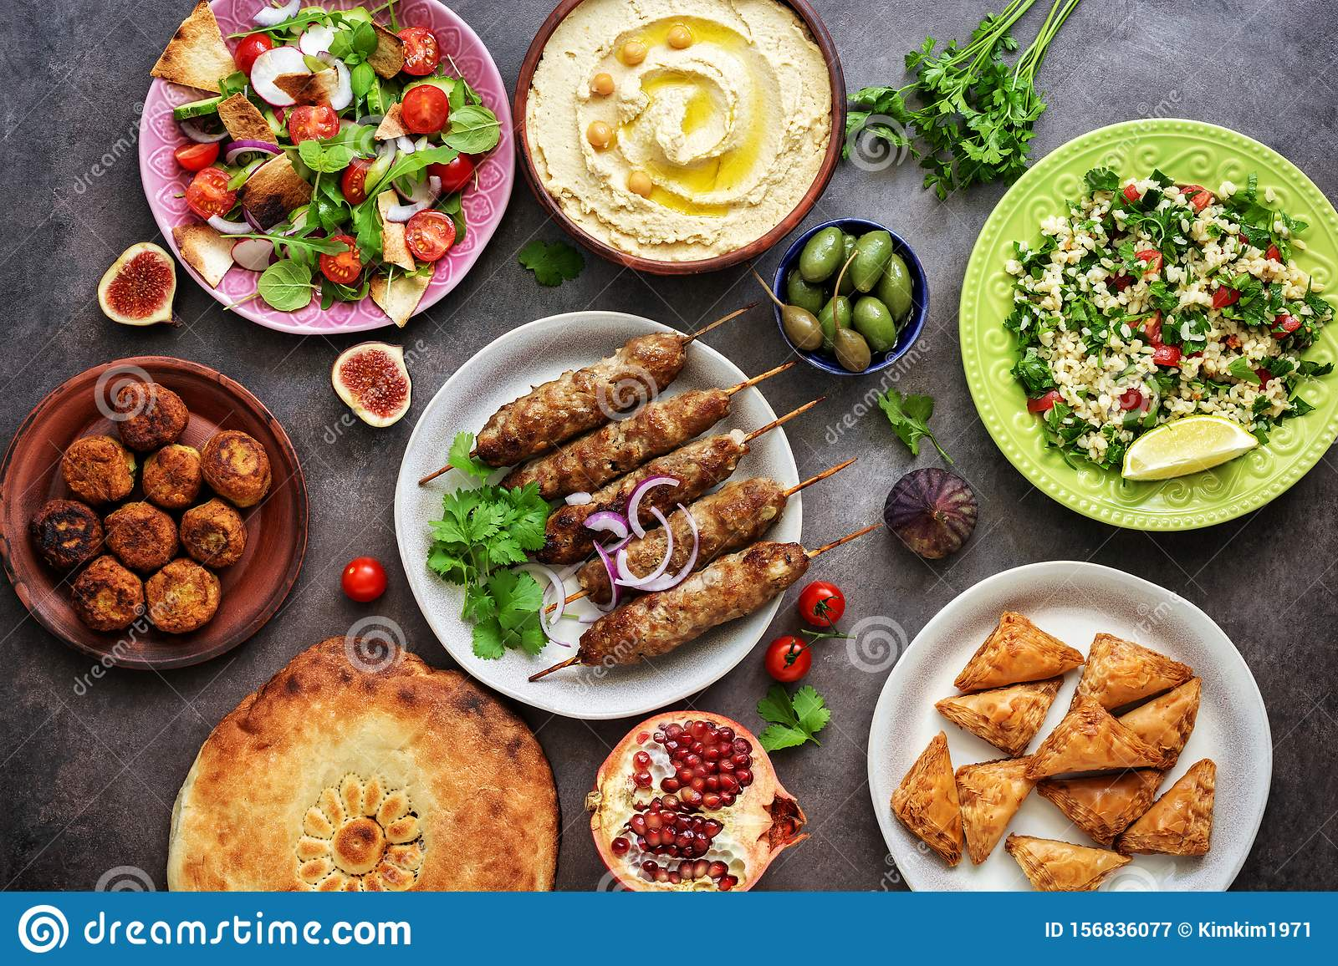

Introduction Section

This final project explores the best locations for a Middle Eastern restaurant in the Manhattan of New York. New York is a major metropolitan area with more than 8.4 million (Wikipedia, 2019) people living within city limits. New York City is the largest city in the United States with a long history of international immigration. People came from many parts of the world. Absolutely one of the most exotic foods of the world is the Arabic cousin or we can say that Middle eastern food style.

Business Problem

1) What is the best location for an Middle East Restaurant in Manhattan, New York City?

2) In what Neighborhood should I open an Middle East restaurant to have the best chance of being successful?

Data acquisition :

Data have been used in this project is from two parts , one is from Wikipedia that has been taken the neighborhood and venue data is from foursquare data calling.For the data analyses we have to analyze New York data set and after that try to make foursquare calls and looking for the best options.

https://cf-courses-data.s3.us.cloud-object-storage.appdomain.cloud/IBMDeveloperSkillsNetwork-DS0701EN-SkillsNetwork/labs/newyork_data.json

1) This data set we have studied in the previous lab and explore for the neighborhood of the New York city as https://cocl.us/new_york_dataset

2) For square callings for the Middle Eastern restaurants :

* We may have three options Greek, Turkish and Arabic style
* Making 3 clusters and looking for a best option which one we will use.
* By using this API we will get all the venues in the Manhattan neighborhood. We can filter these venues to get only option we have chosen (Greek, Arabic or Turkish) restaurants.

Data Cleaning and Approach:

* Collect data : Data Source: https://cocl.us/new_york_dataset
* Making forsquare callings for best vanues
* Cleaning data for middle east restarants
* Clustering the best locations of vanues
* Comparing

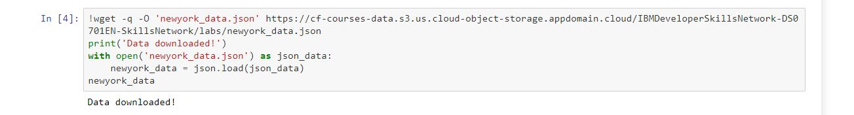

Our data frame is:

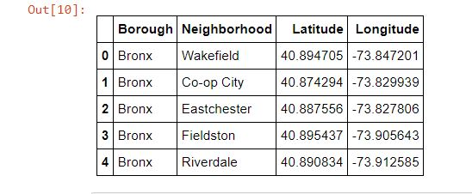

Using geopy library for getting coordinates

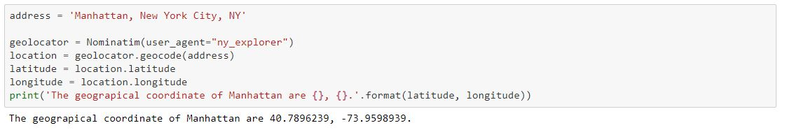

Fosauare location Data:

Using fosquare calling we have oportunity to see locations of the restarants an also popularities.

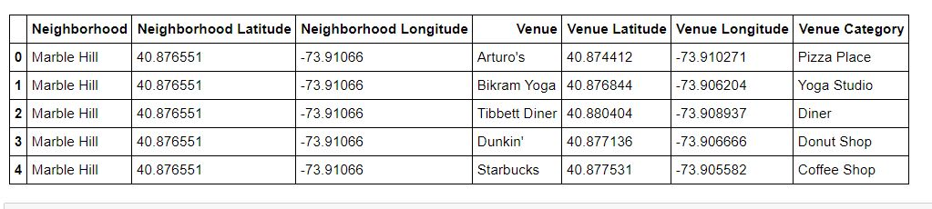

Explatory Data analysis:

There are 331 unique categories and we have some options as similar middle east restarant categories as Turkish, Kebab , Middle eastern and Lebanese Restarants are our targets in this data analysis.

After this step we select just neighborhood and the restaurants

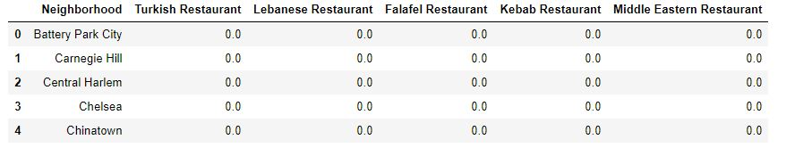

We will examine our restaurants in 5 clusters in most common places and we will return our target audience which are the best options to opening a good investments.

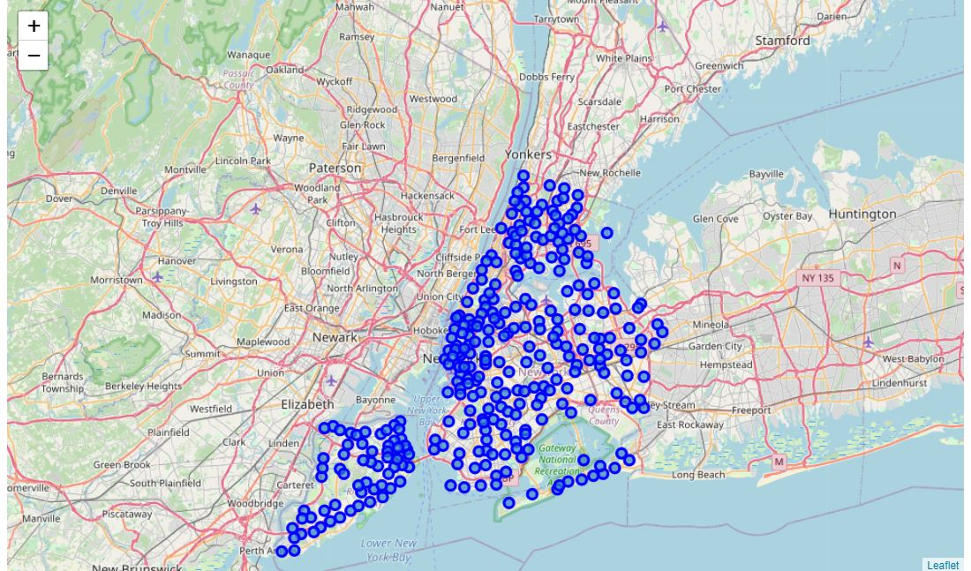

We will have 5 clusters to examine in each clusters our restaurants options

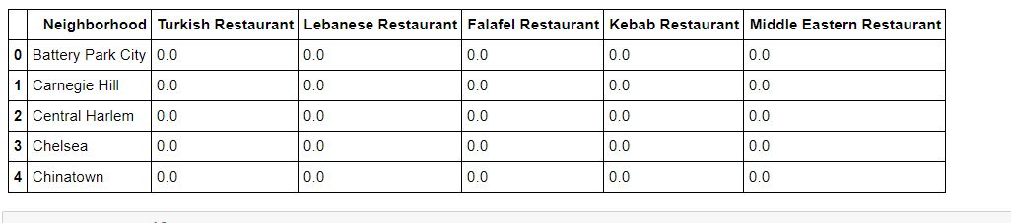

1Cluster:

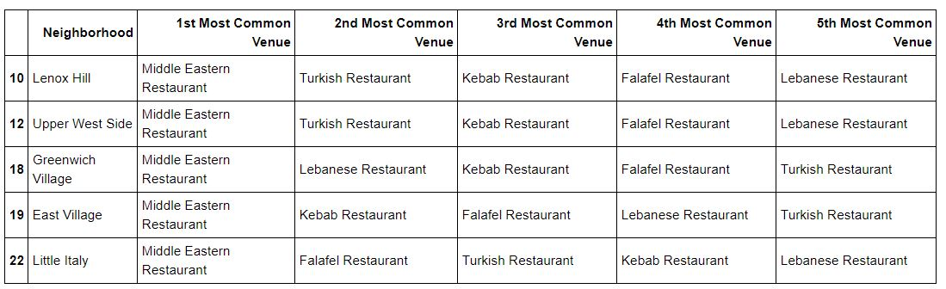

2nd Cluster:

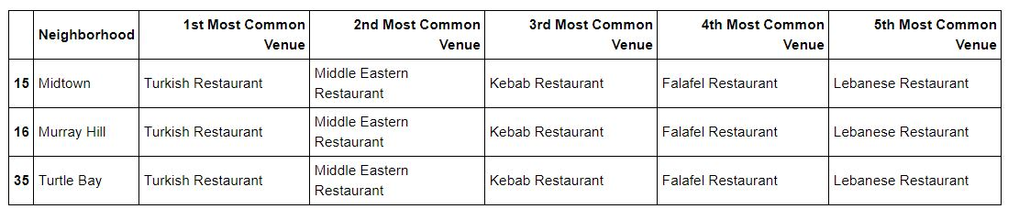

3rd Cluster:

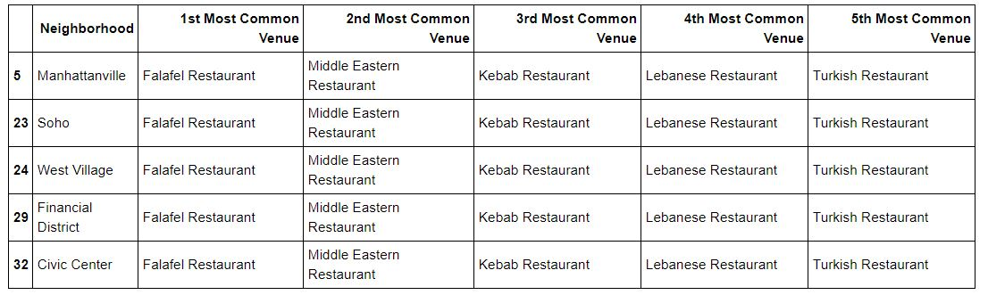

4th Cluster:

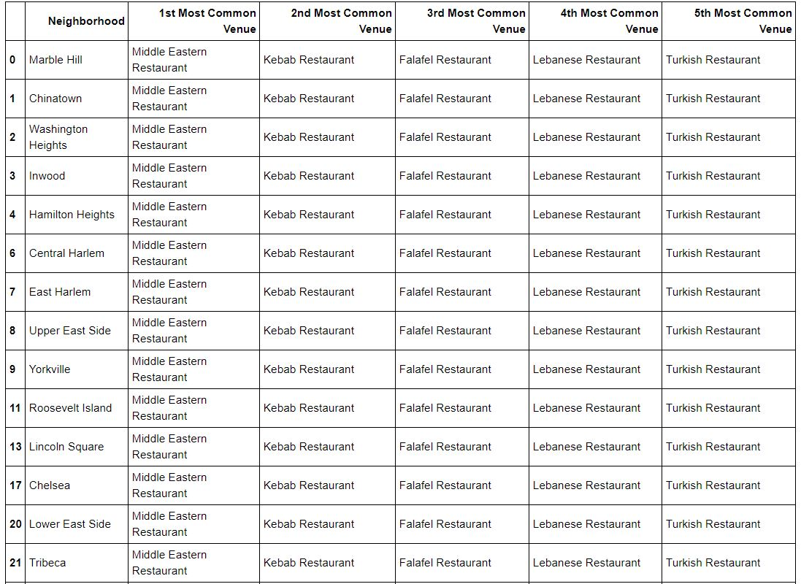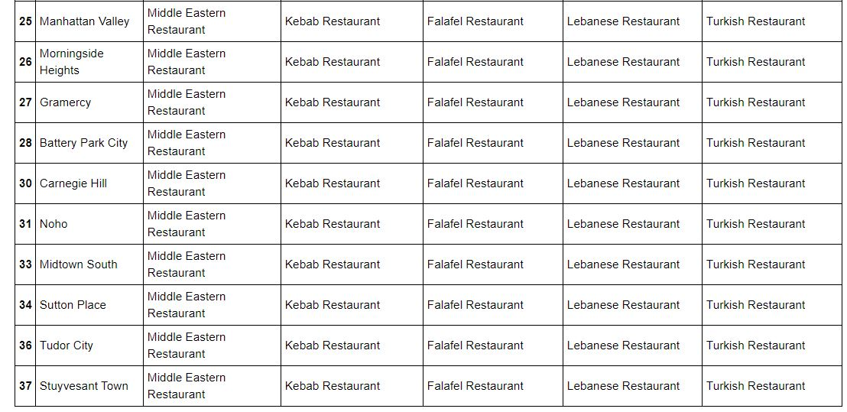

5th Cluster:

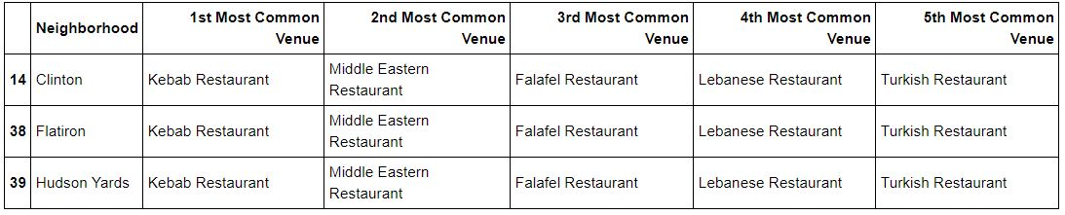

Map of the Clusters:

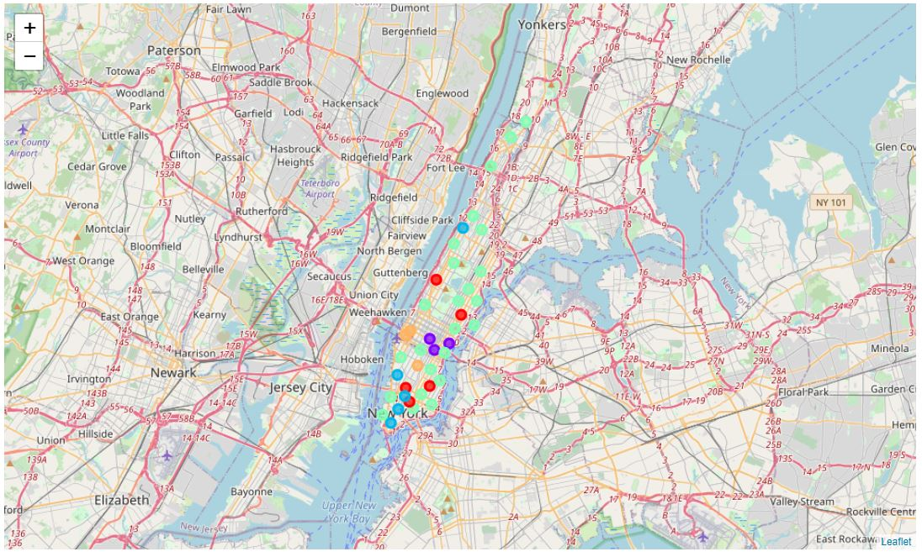

Visualization:

Manhattan is a place that one of the most international attraction and touristic places in the world, also very attractive for the international tourists and also american residants like to visit and they have to eat in this place during their staying.

As we see in the graphics Midtown and turtle bay has mor popularity in Turkish Restaurants.



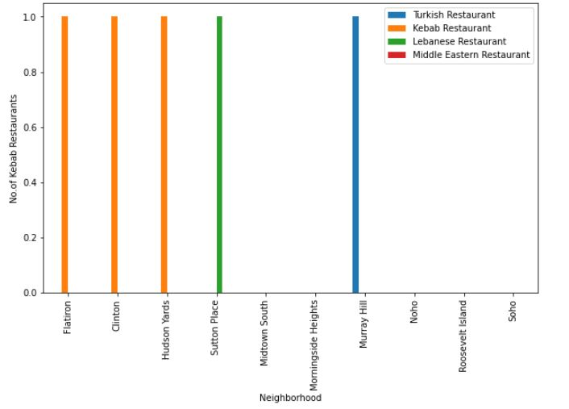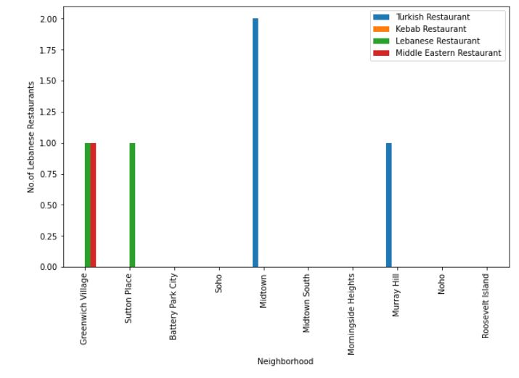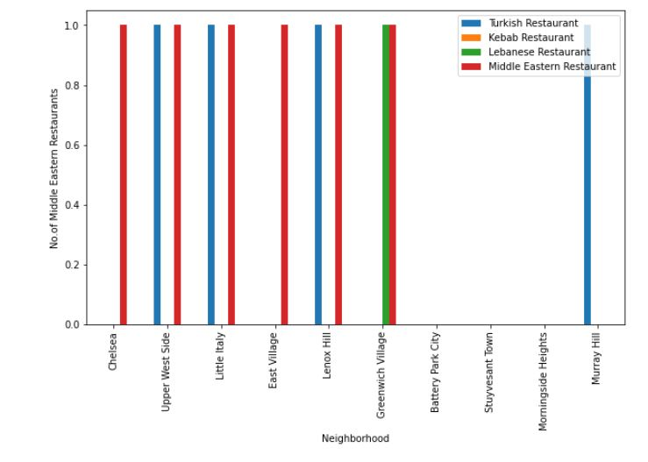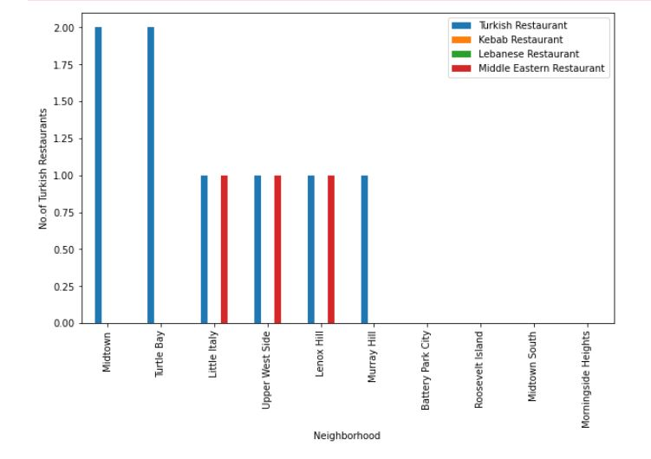

Results:

* 1. Midtown has more intense Turkish Restaurant
  2. Cluster 0 and 3 has more middle east restarants in Manhattan
  3. Between the options between the Turkish, lebanese, falafel and Middle eastern restaurants we may name as Middle East Tastes

Discussion:

We have until now just names as Turkish, lebanese, Falafel and middle eastern Restarants bur there is no arabic restarant. Also there are in a scattered area in Manhattan. Between the Turtle bay or midtown are the best result as an option to select place to open.

Conclusion:

It was my first data analysis in my coursera capstone project, trying to use json file, graph other exploratory data analysis. Use Foursquare API calling for Manhattan and New York boroughs and their neighborhoods. It show me that we can detailly search and analyses a lot of brilliant ideas. Also, from restaurants to apartment sales, to offices. It is very useful.